**25th meeting of the Club of Invertebrate Neurobiology**

St-Germain-au-Mont-d’Or, May 12th-13th, 2025

REGISTRATION

Please return this document by e-mail ([cni-2025@listes.crnl.fr](mailto:cni-2025@listes.crnl.fr))

before the deadline: April 21st 2025

Name: First name:

Status:

Laboratory / Team:

Address of the laboratory:

Phone number:

E-mail:

**Presentation**:

🞏 Oral

🞏 Poster

🞏 No presentation

**Abstract**:

**Registration Fee includes:**

-Participation at the CNI meeting

-Monday evening dinner, **Overnight accommodation** and Tuesday lunch. An overnight “get together” will also be organized with drinks and good spirit.

-Coffee breaks

To maintain affordable prices and encourage interactions, registration is only available with overnight accommodation.

Statutory member: 200 € (including 19 € CNI membership)

PhD Student / Postdoc: 135 € (including 19 € CNI membership)

**Accomodation and food preferences**

All the bedrooms have two beds.

🞏 I am happy to share.

If you wish to share the room with a particular person, please provide the name of your roomate here :

🞏 I would like a room all for myself.

Please note that based on the number of participants who will register the possibility to book a single person room will be limited. Also, a 15€ will be added to the fees and the payment will be requested upon arrival at venue.

Please tell us your food preferences:

🞏 vegetarian meal

🞏 food to be avoided (allergy) :

**Payment** (Payment deadline: April 21st, 2025)

Only one way of payment: Make a bank transfer using the following RIP

If a bank transfer is not possible for you, contact us to use a check.

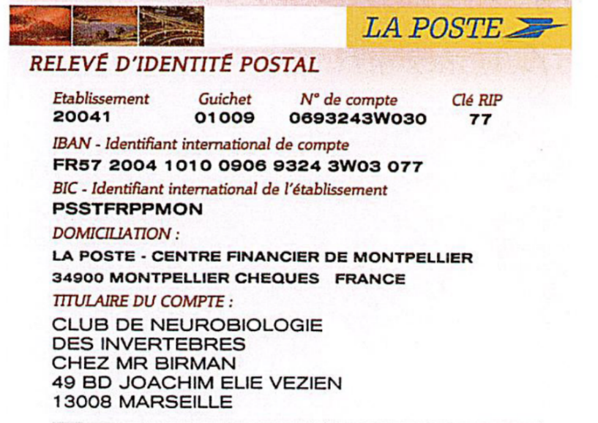

**IMPORTANT:**

CNRS/INSERM Purchase Orders (“bons de commande” are NOT accepted. Sorry but it is just

not possible with an “Association de type loi 1901”). You can pay by yourself and we will give

you an attestation to be reimbursed.